Mastering Embedded Systems Online Diploma
www.learn-in-depth.com

First Term (Final Project 2)
Eng. mahmoud Elyamani

My Profile:
www.learn-in-depth-store.com/profile/mahmoud-elyamani-7/profile

.Txt file:
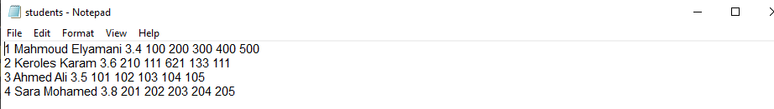
- For code preview please check out Github Link to my project as it is too big to paste screenshots of it here.

Case(1): Adding students details from .txt file:
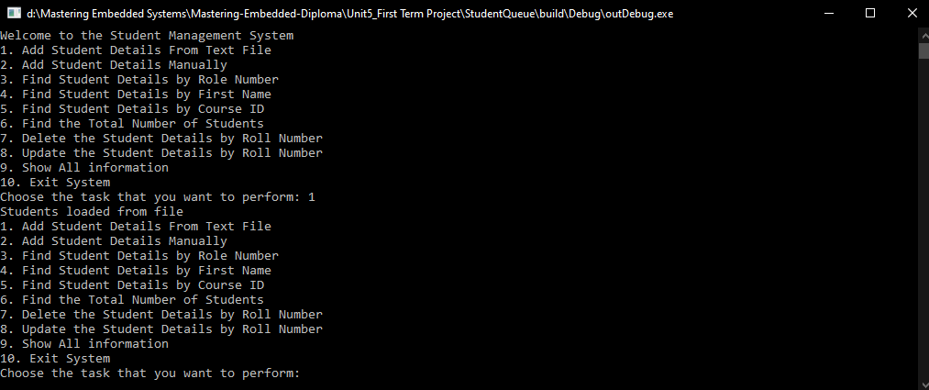

Viewing the students after adding:
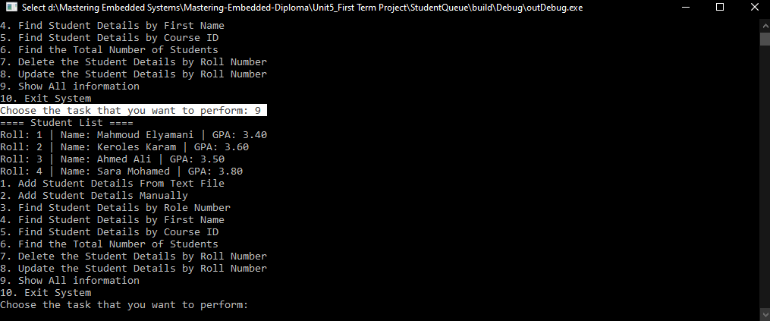

Case(2): Adding a student manually through the terminal

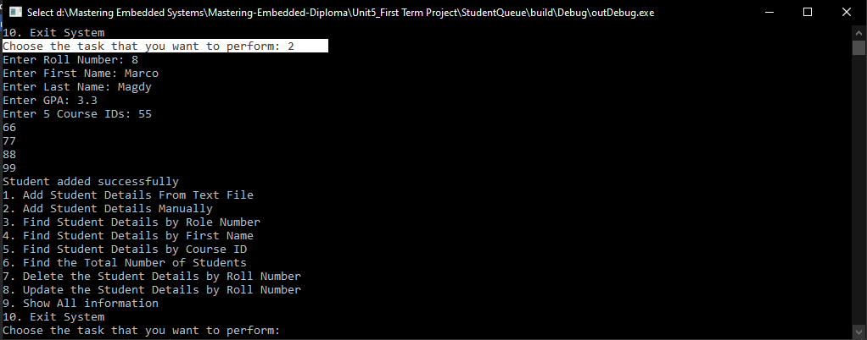

Viewing changes:
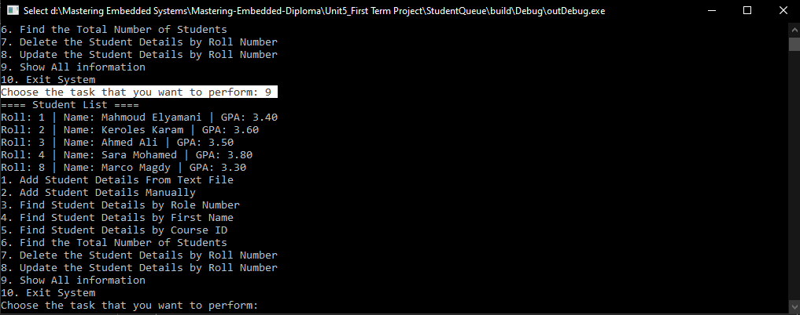

Case(3): Reviewing student’s details by role number:
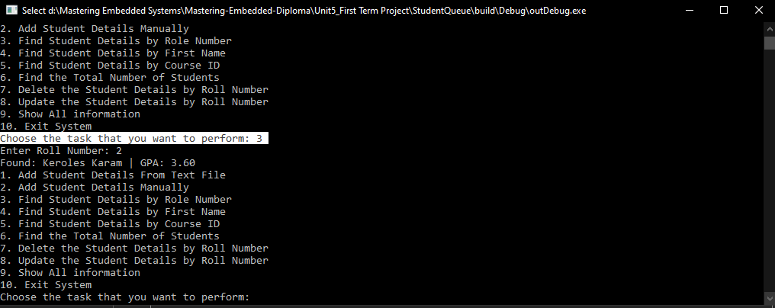

Case(4): Reviewing student’s details by first name:
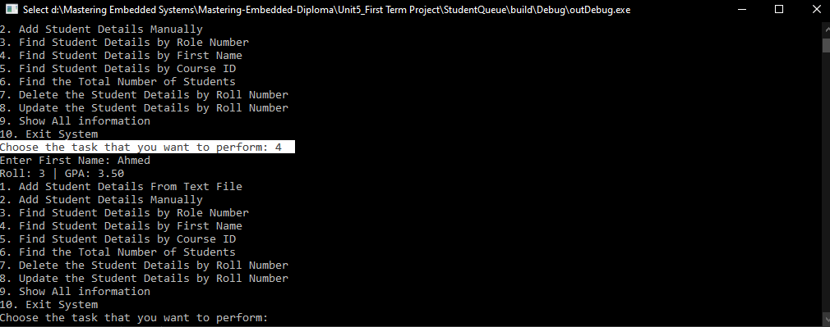

Case(5): Reviewing student’s details by course ID:
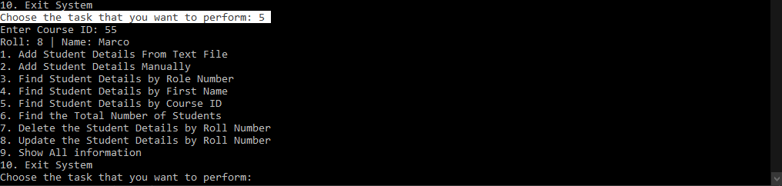

Case(6): Finding the total number of students
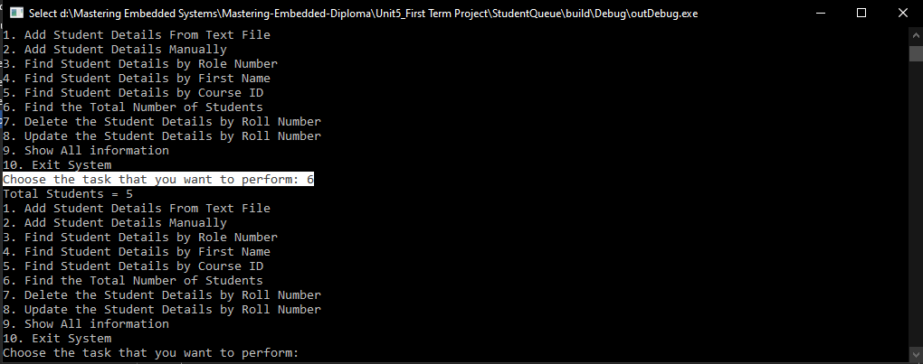

Case(7): Deleting a student then checking the total again
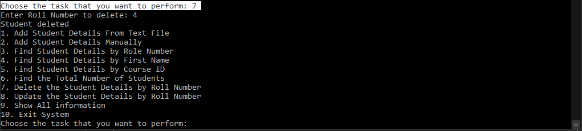
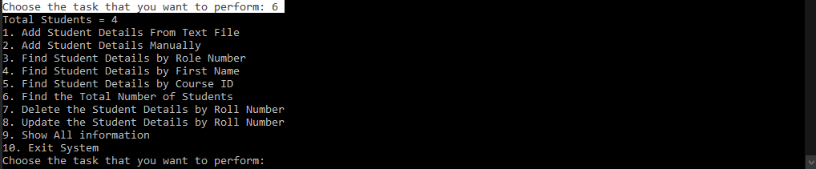
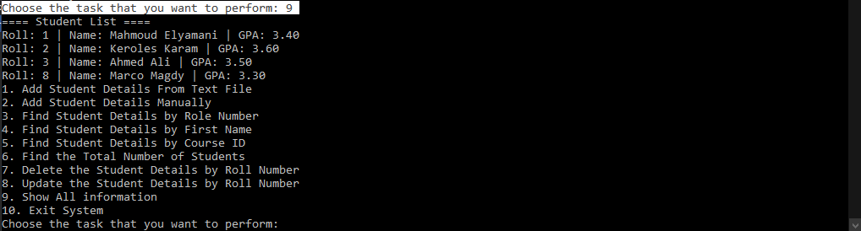

Case(8): Updating student’s info by role number
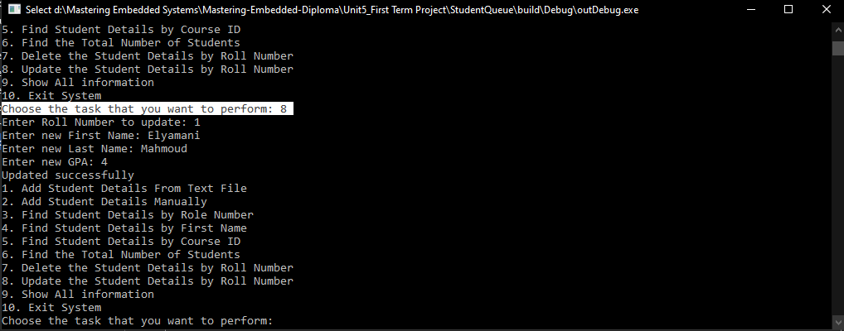

Case(9): Showing all students after editing
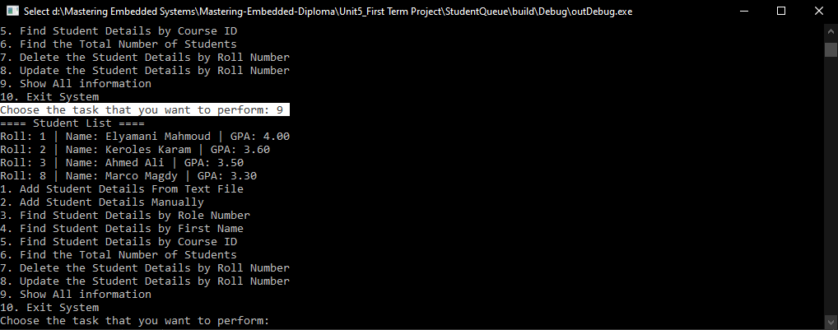

Case(10): attempting to view a non-existent role number:
